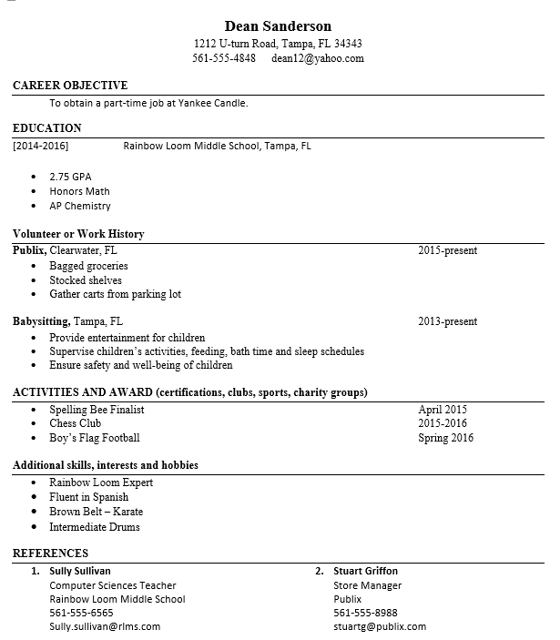
Sample Finished Project

Microsoft Word Skills – Resume’ Lesson
Please create a resume for your application to a summer job or part-time high school job. Make sure there are no spelling or grammar errors. When you are finished please save the file as “Last Name + First Name + Resume” and send it to me for grading. Once approved, we will print one copy out.

- Your resume’ should be no longer than 2 pages (ideally it should be one page)
- Think hard as you have more activities, skills, clubs, awards, honors, advanced classes and work experiences than you think
- Use the Resume’ builder on page 3 as a pre-activity to assist you in gathering everything you’ll need for the actual resume
- Copy and paste the Resume’ template on page 4 into a new blank Microsoft Word document and begin working on your real resume’
- Make sure there are no spelling or grammar errors [Review Tab]
- I have provided you with an example resume’ above

Resume’ Builder

Name

Home Address

Home Phone

Email

Career Goal

Education

Work Experience (paid or unpaid)

Volunteer Experience (Library, babysitting...)

Awards (Perfect Attendance, Honor Roll, Athletic Award, Student of the Month…)

Computer Skills (Office Programs, Coding, blogs, video editing, web site building…)

Extracurricular Clubs and Activities (SGA, Robotics, Chess, Girl Scouts…)

Other Skills (musical instrument, sewing, cooking…)

References (one non-parent is fine, a teacher or family friend)

FIRST AND LAST NAME
Local Address, City, State Zip Code
Phone Number Email Address

CAREER OBJECTIVE [The career objective defines what you are seeking in your career. It must always be relevant to the position that you are applying for]
Examples:
To obtain a part-time job at a clothing retail store in the mall.
To obtain a part-time lifeguard job on Fort Lauderdale Beach.

EDUCATION
[Date attended school] [Insert name of school(s) attended or attending here with locations]
[GPA, Special Classes…]

VOLUNTEER OR WORK HISTORY
[Insert Name of Work Here], [Insert work location here] [Insert work dates here]
Duties include:

Insert Name of Work Here], [Insert work location here] [Insert work dates here]
Duties include:

ACTIVITIES AND AWARDS (certifications, clubs, sports, charity groups)
- [Insert activity, award or honor here] [Insert award date here]
- [Insert activity, award or honor here] [Insert award date here]
- [Insert activity, award or honor here] [Insert award date here]
- [Insert activity, award or honor here] [Insert award date here]

ADDITIONAL SKILLS, INTERESTS AND HOBBIES
- [Insert additional skill here]
- [Insert additional skill here]
- [Insert additional skill here]
- [Insert additional skill here]
REFERENCES
- [Insert reference name]
[Insert position title]
[Insert business/organization name]
[Insert contact phone number]

- [Insert reference name]
[Insert position title]
[Insert business/organization name]
[Insert contact phone number

Skills taught:

• Font and Paragraph Formatting
• Indents and Line Spacing
• Bulleted Lists
• Resume's

